A CRM APPLICATION TO MANAGE THE MALL

**Team members: Naan Mudhalvan ID:**

SEDHURAMAN K 9297B29A0C7268182614B37EAFA496B7

SYED JAVITH BASHA H 2D8EF253C9645FBAE404C3D69EA095CC

YUVARAJ M 02A8CCBDCAE0084A2D24A9252B397003

THAMIZHMANI B 02A8CCBDCAE0084A2D24A9252B397003

Naan mudhalvan project report

1.Project Overview:

This project involves the development of a Customer Relationship Management (CRM) application tailored for mall management, leveraging the Salesforce platform for its robust features and scalability. The application is designed to manage tenants, leases, and issue tracking efficiently. It includes creating custom objects such as Tenant, Lease Tracking, and Tenant Issues, along with corresponding fields, relationships, and custom tabs.

A Lightning App will integrate these components for seamless navigation. Automation is implemented using flows, including record-triggered and scheduled flows, while Apex triggers handle advanced logic like email notifications for unpaid rents and validation for PAN card entries. Asynchronous Apex is utilized for scheduled tasks, and detailed reporting and dashboards are provided for lease management, tenant issues, and overall tenant data. This comprehensive solution aims to streamline mall operations and enhance tenant management.

2.Objectives:

The primary objective of this project is to design and implement a robust CRM application using the Salesforce platform to streamline mall management operations. The system aims to efficiently manage tenant information, lease agreements, and tenant issue tracking while providing actionable insights through reports and dashboards.

By creating custom objects like Tenant, Lease Tracking, and Tenant Issues, the application ensures that all critical data points are captured and organized. The integration of custom tabs and a Lightning App allows for intuitive navigation and centralized access to relevant information. This application enhances operational efficiency by automating key processes, such as sending email alerts for unpaid rents and validating tenant PAN card entries, ensuring accuracy and timely follow-ups.

Another key objective is to harness Salesforce’s capabilities to deliver a data-driven approach to mall management. Through the creation of flows and Apex triggers, the application automates repetitive tasks, saving time and minimizing human errors. The use of asynchronous Apex ensures that scheduled processes run seamlessly without affecting system performance. Additionally, by generating comprehensive reports and dashboards, the application provides stakeholders with valuable insights into tenant performance, lease management, and issue resolution trends. Ultimately, this project seeks to enhance tenant satisfaction, reduce administrative overhead, and empower mall management with tools to make informed decisions.

3.Salesforce key Features and concepts Utilised:

* **Custom Object and fields**:

Custom objects like Tenant,Lease tracking and tenant issues are created to capture specific mall management data. These objects include Tallored fields and relationships to ensure accurate and relevant information storage.

* **Lightning app Builder**

A customer Lightning App is designed to provide a centralized and user friendly interface for managing tenant data, lease agreements, and issue tracking within the salesforce environment

* **Automation with Flows**

Record triggered and scheduled flows are implemented to automate repetitive processes,such as generating alerts for lease renwals or tracking overdue rents enhancing operational efficiency.

* **Apex Triggers and Asynchronous Apex**:

Advanced business logic is implemented using Apex triggers for tasks like sending email notifications for overdue payments and validating tenant data. Scheduled Apex jobs are utilized for time-based automated tasks.

* **Reports and Dashboards:**

Custom reports and dashboards are created to provide actionable insights into lease management, tenant performance, and issue resolution trends, enabling data-driven decision-making.

4.**Solution Design Steps for the Salesforce Mall Management CRM Application:**

* **Create custom objects:**

we should create a custom objects in salesforce, follow these details:

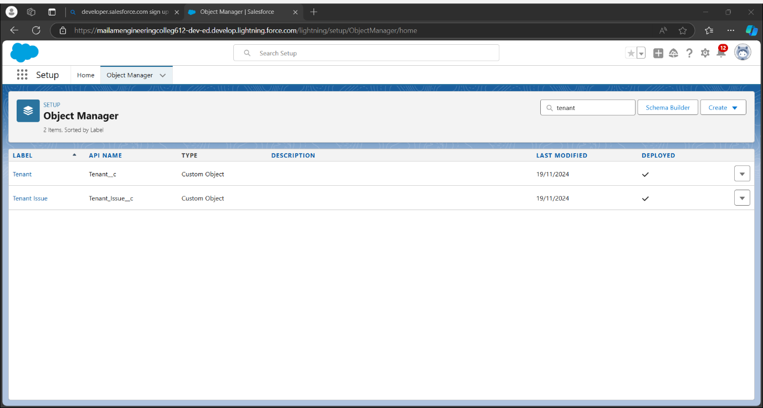

* **Create a tabs:**

Tabs in a CRM (Customer Relationship Management) application for a mall typically serve as organized sections to manage various aspects of customer and business interactions. Here are common tab ideas.

Overview of key metrics, such as footfall, sales data, and tenant performance.

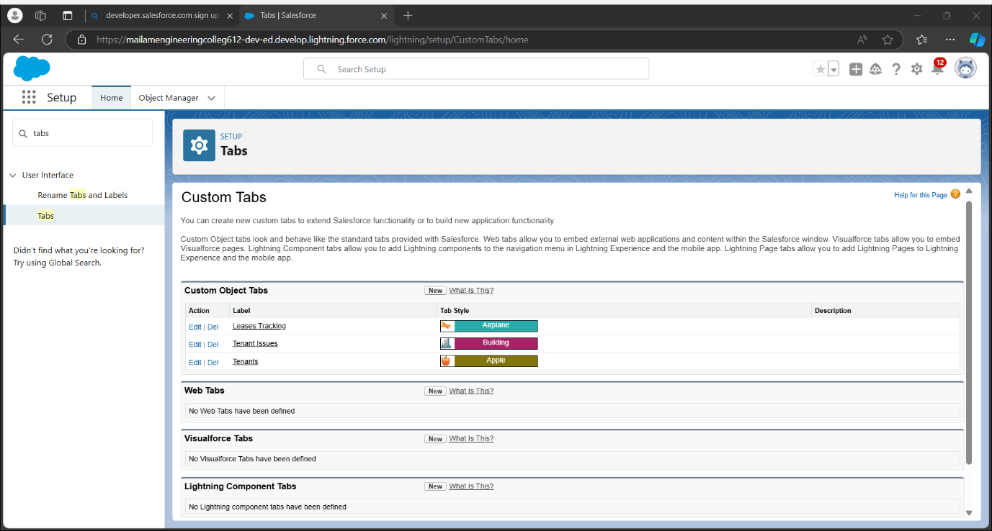

* **Create fields on tenant objects:**

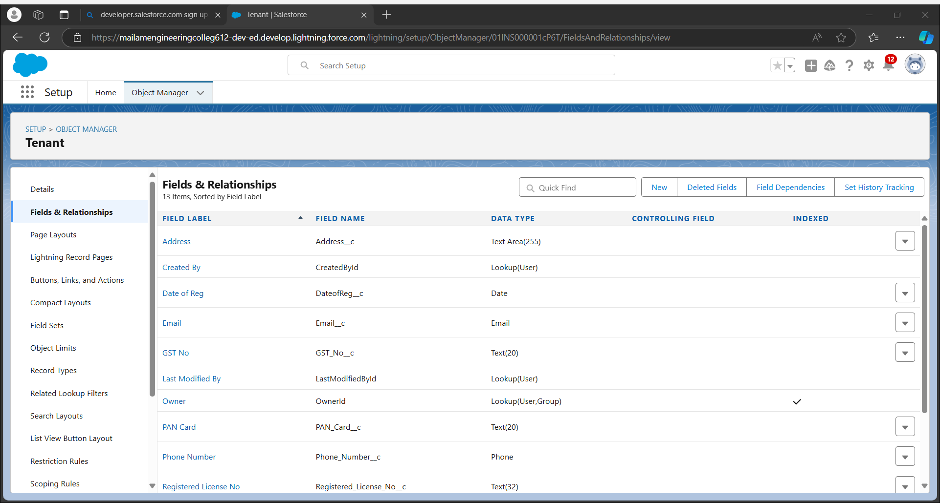

* **Create fields on lease tracking:**

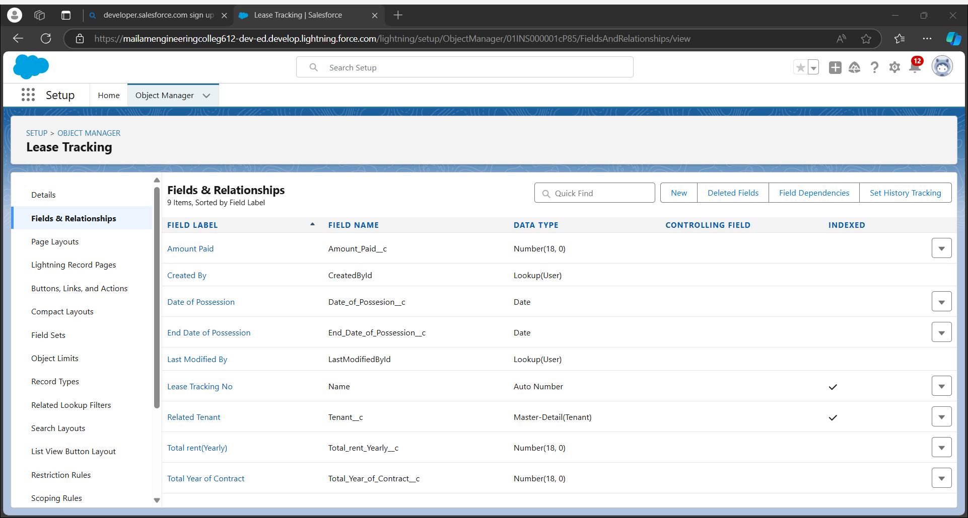

* **Create fields on Tenant issues:**

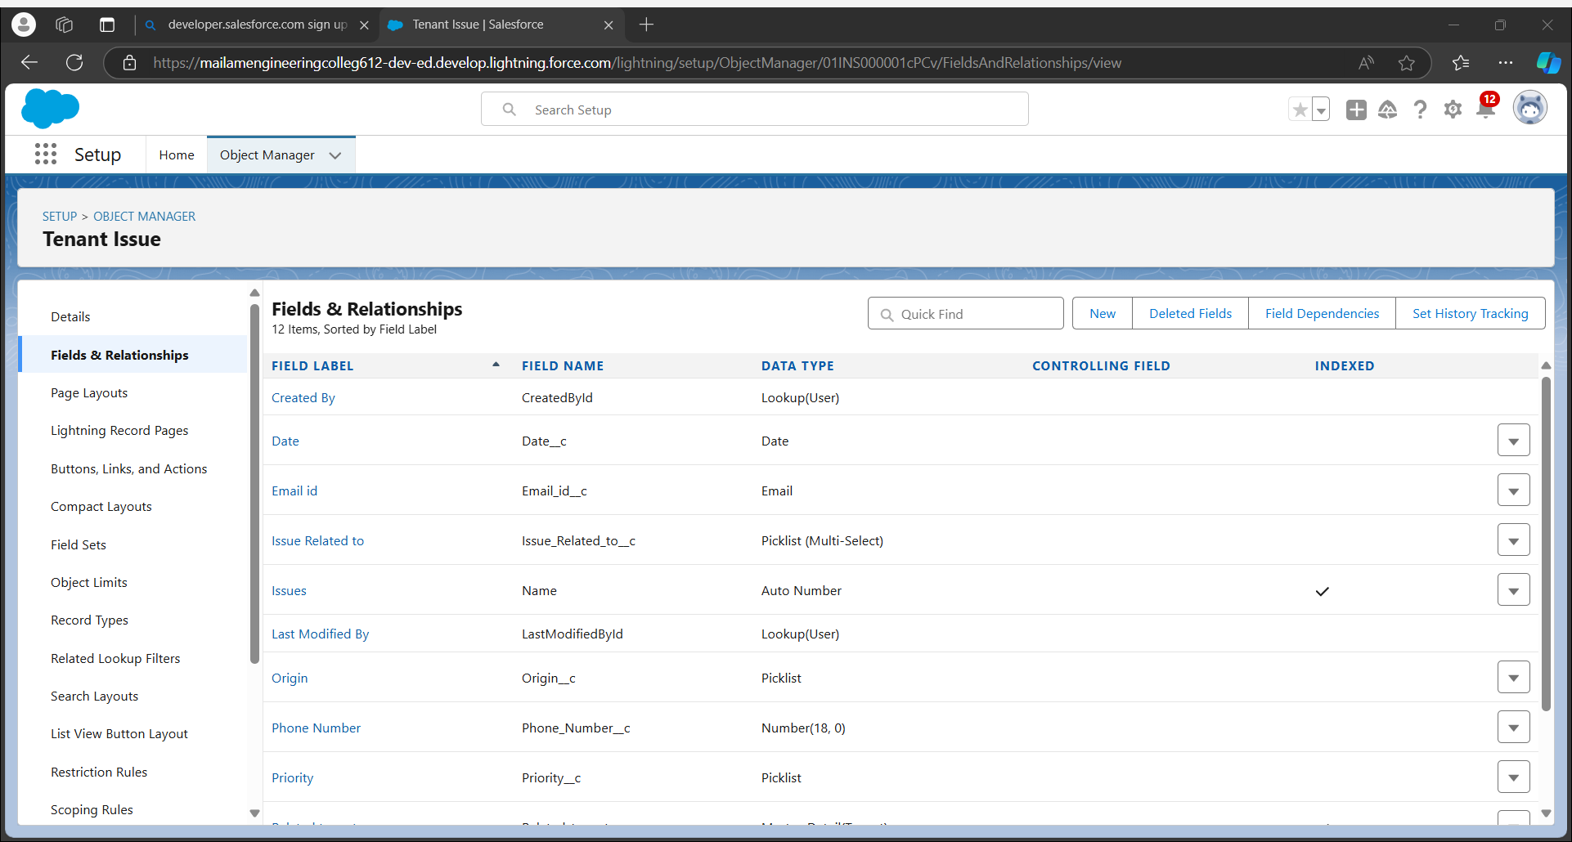

* **Create a lightning app:**

Create a custom Lightning App that integrates the following components:

Opportunity records

Automobile information records

Invoices related to opportunities

The app should include:

Navigation to all relevant objects

A dashboard to visualize total Sales, Invoices due, opportunity stage

Inserting records into tenant object:

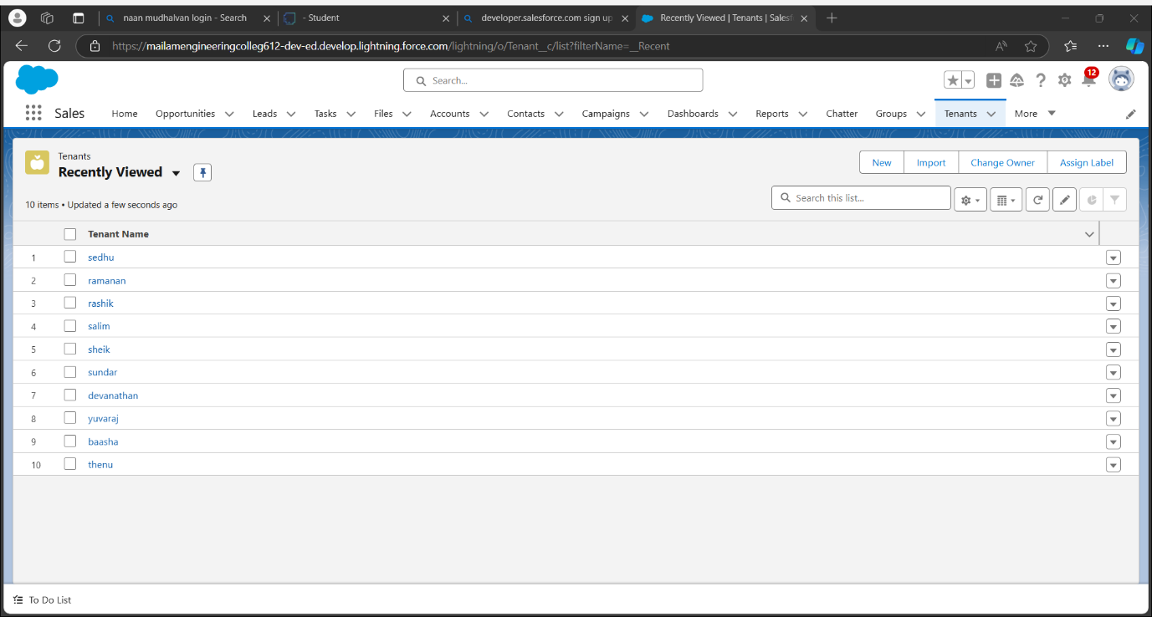

Inserting records in lease tracking:

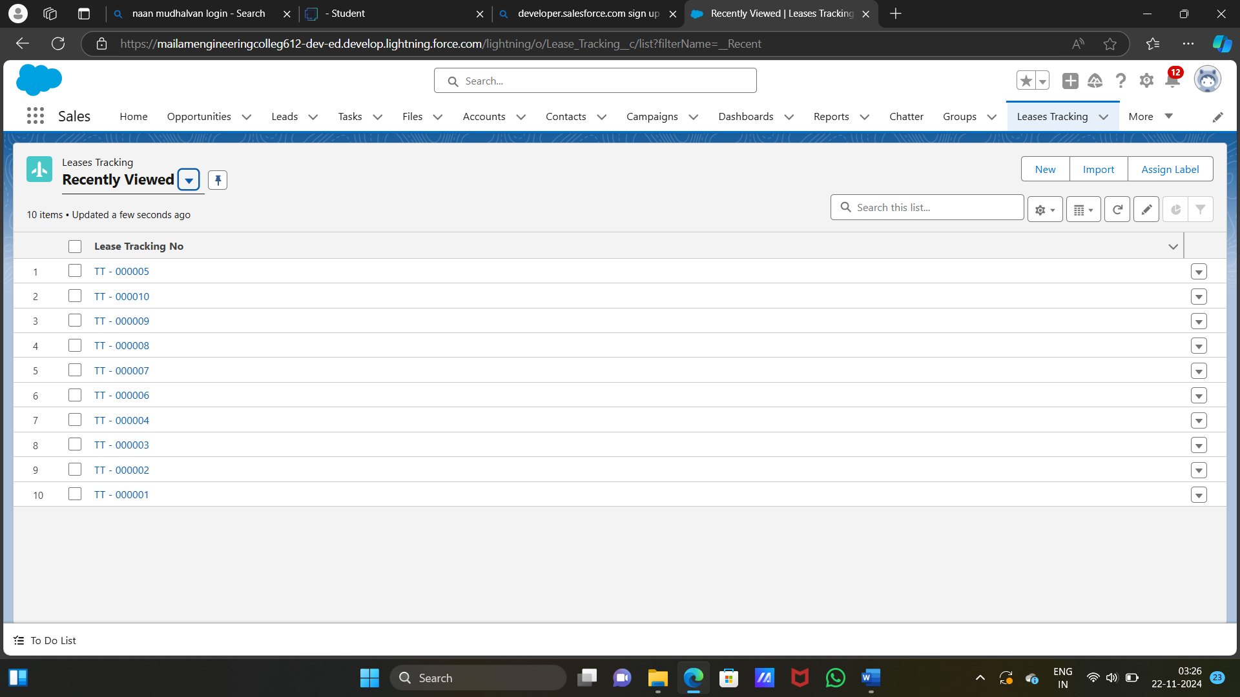

Inserting records in tenant issues object:

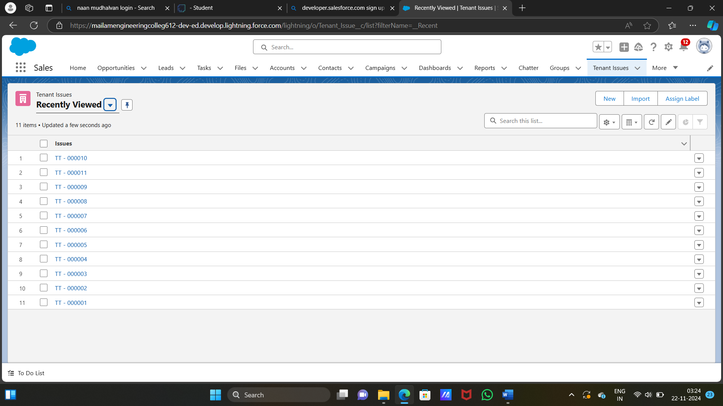

* **Create flows:**

Designing a CRM(Customer Relationship management) application for a mall involves creating a set of comprehensive, user-centric workflows to optimize operations and working flow model was created

Below are the detailed flow on the tenant object:

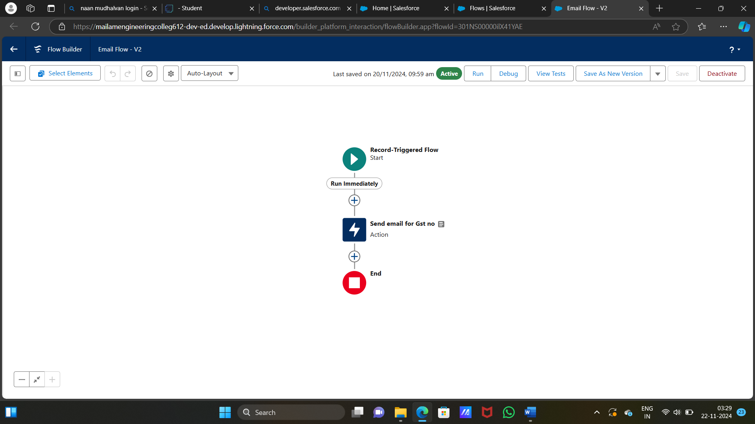

* **Creating a flow on lease management object:**

In lease management the control flow through the start and then it will goes for the records and finally it will end in the flow

The object was created in the record and object was managed to get a control flow

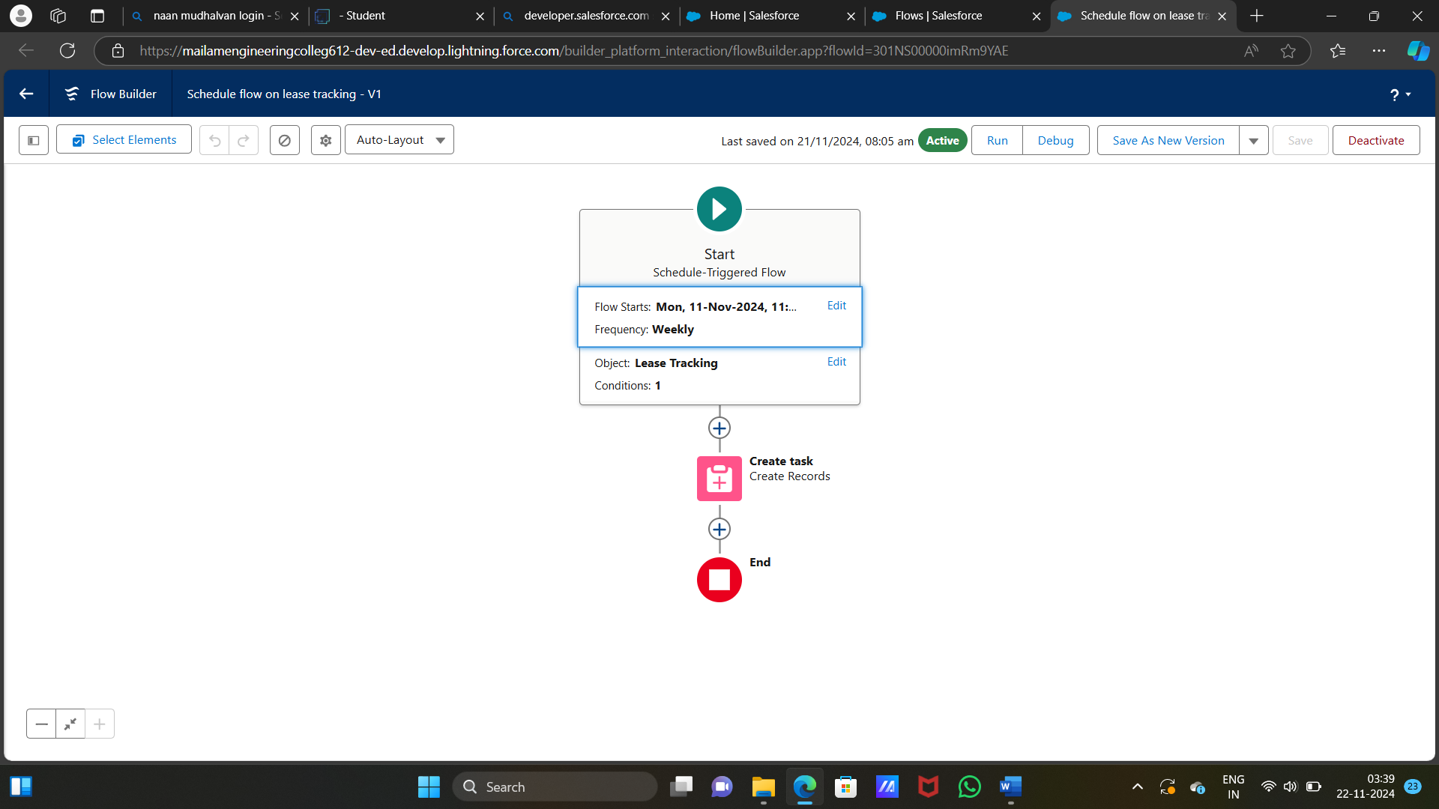

**Apex Triggers:**

In Apex trigger creating the lease tracking trigger and lease tracking trigger handler and this is to handle the error in the lease tracking trigger and this was handled.

An apex trigger is a set of instruction that execute when certain events occur on a salesforce object

* **Lease Tracking Trigger:**

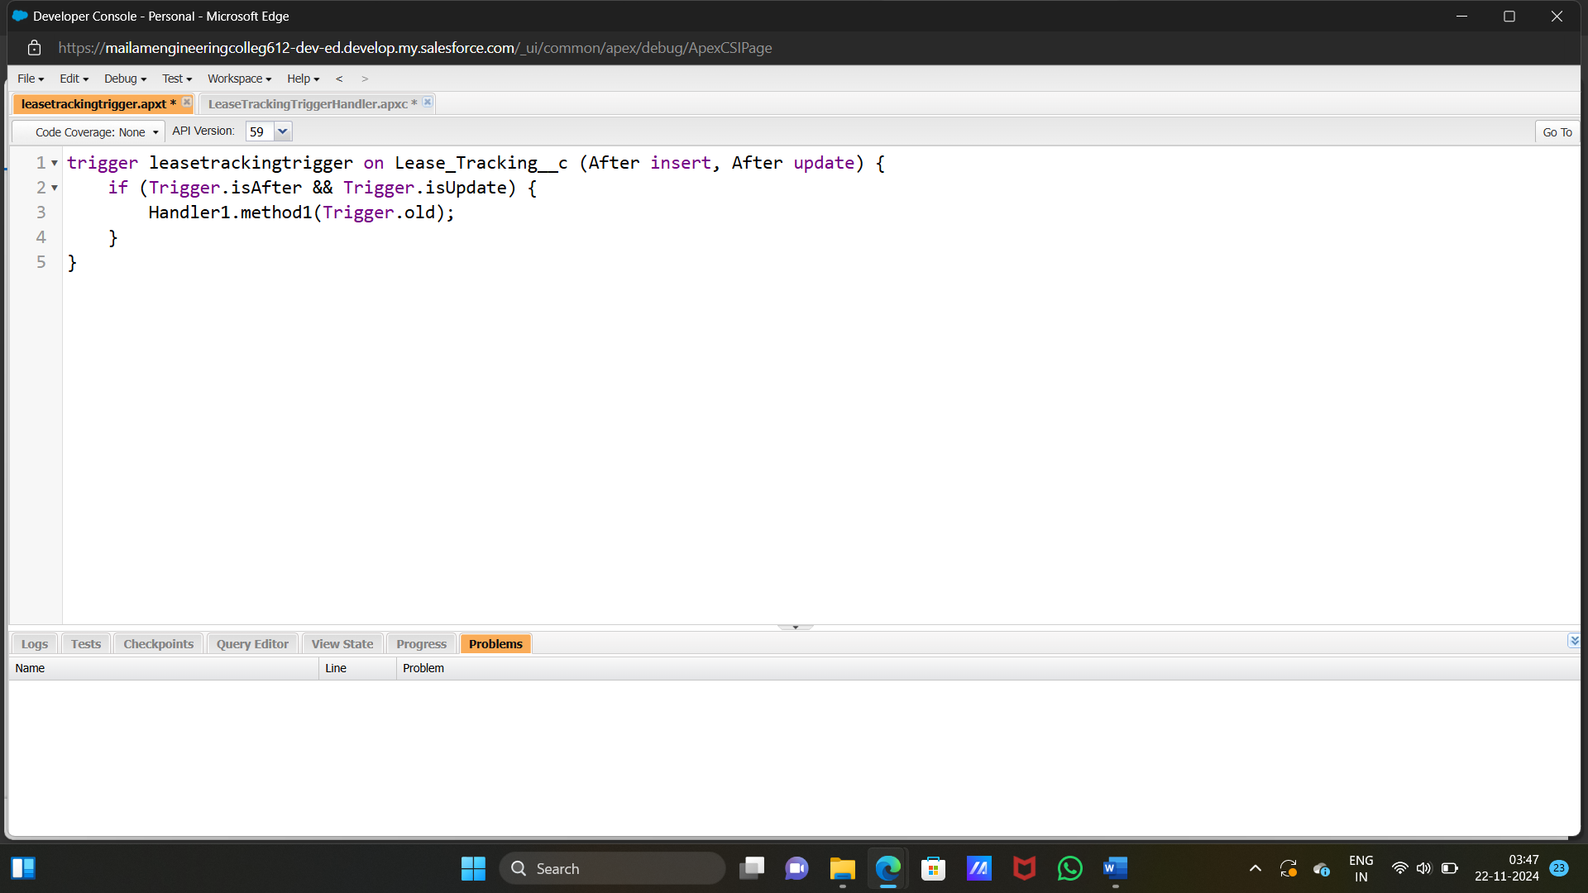

**Lease tracking trigger handler:**

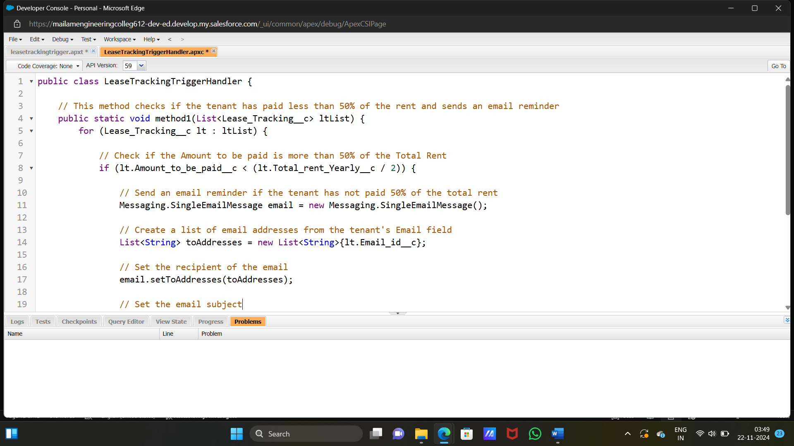

* **Asynchronous Apex:**

Asynchronous Apex can be applied to CRM systems for a mall to handle operations that are long-running, resource- intensive, or time-dependent, such as sending notifications, processing tenant records, or updating analytics dashboards. Below are examples of Asynchronous Apex implementations, including Scheduled Apex for specific scenarios in a mall CRM application.

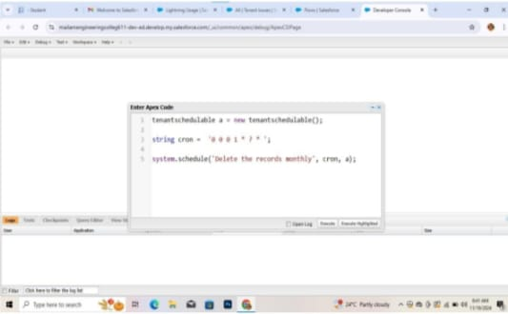

✓ Reports:

Reports give you access to your Salesforce data. You can examine your Salesforce data in almost infinite combinations, display it in easy-to-understand formats, and share the resulting insights with others. Before building, reading, and sharing reports, review these reporting basics.

• Create A Report of lease Management Records:

Lease management records play a critical role in the administration of real estate properties, especially for commercial spaces like malls, office buildings, or residential complexes. A well-organized lease management system helps property managers track lease agreements, rental payments, terms, renewals, and compliance with lease conditions

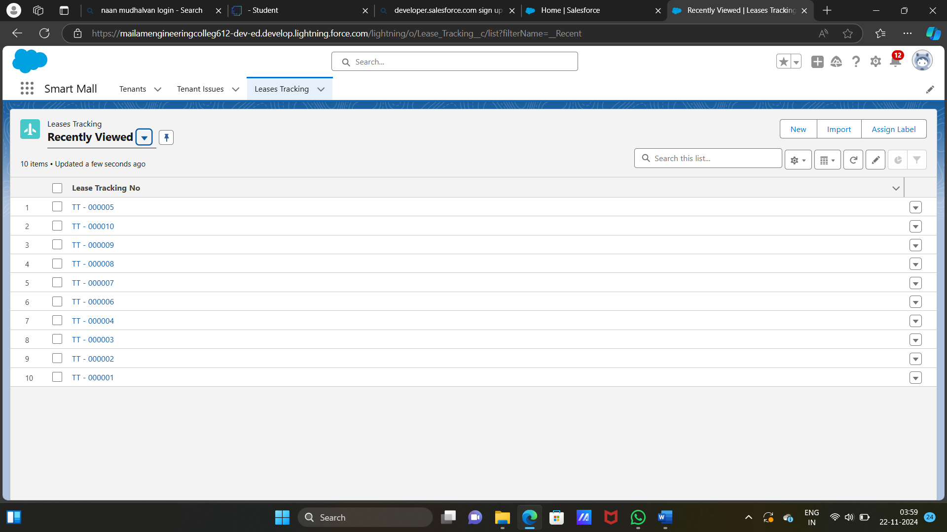

* **Create report of tenant issues:**

This report will outline the key components of lease management records including the structure data and key performance indicators relevant to the key

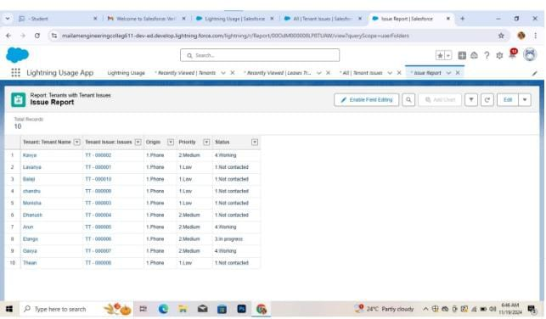

* **Dashboard:**

A dashboard provides a visual overview of real-time data, helping you monitor and analyze business trends, track key metrics, and make informed decisions based on current information. It's an effective tool for spotting patterns, assessing performance, and measuring the outcomes of various activities.

A structured process used to review, verify, and approve workforce-related tasks or transactions. This ensures that actions like hiring, promotions, leave requests, and payroll updates align with company policies and are properly recorded.

**5.Testing and validation of CRM application for the mall project:**

Testing and validating the CRM system for a mall is vital to ensure it functions properly and provides a smooth experience for both customers and mall management. The process begins with functional testing to ensure key features like customer registration, profile management, loyalty programs, and marketing campaigns work correctly. Usability testing follows, focusing on the system's ease of use, mobile responsiveness, and overall user-friendliness for both customers and mall staff

Next, performance testing checks how the CRM handles heavy traffic, especially during peak shopping periods or promotions, and whether it can scale as the mall grows. Security testing ensures the protection of customer data and compliance with regulations such as GDPR. Integration testing makes sure the CRM works well with other mall systems, such as POS, payment systems, and tenant management software.

User acceptance testing (UAT) involves real users to confirm the system meets business needs and delivers the expected results. Throughout the process, any issues are documented, prioritized, and fixed before the system is fully deployed. After the launch, ongoing monitoring and collecting feedback are essential for identifying and addressing any new issues, ensuring the CRM continues to effectively support the mall's operations.

* **Conclusion:**

In conclusion, adopting a CRM system for a shopping mall offers a competitive edge by consolidating customer data, improving operational workflows, and fostering stronger customer interactions. The CRM enables the effective management of customer relationships through tailored marketing efforts, targeted offers, loyalty programs, and responsive support. It provides mall management with critical insights into consumer behavior, sales trends, and the success of marketing campaigns, facilitating more informed, data-driven decisions. Furthermore, by integrating with other systems such as point-of-sale, tenant management, and inventory tracking, the CRM ensures a smooth, cohesive experience for both shoppers and mall operators. In the end, the CRM system not only enhances customer satisfaction and loyalty but also drives the mall’s growth and boosts operational efficiency, making it a vital tool in modern retail management.